Happy Guitar Tutorial
Hi there! My name is Fluffy. I’m here to tell you how to use and navigate through Happy Guitar learning software. So, sit down comfortably and relax. It will take only a couple of minutes.

First step, installing the software is already done. Oh, is it not? Don’t worry, this one’s simple. Just double-click on a setup file and follow further instructions. Everything should go smoothly. If there’s some problem, ask you parents to install the software for you.
After installing the software, there is a guitar icon on your computer desktop. Click on it.

How should I begin? :: Main screen
Have you seen the blast? That was my friend. Don’t worry about him he’s all right, just a little bit crazy. He’s doing that blast thing all the time :)

Now you should see Happy Guitar main screen.
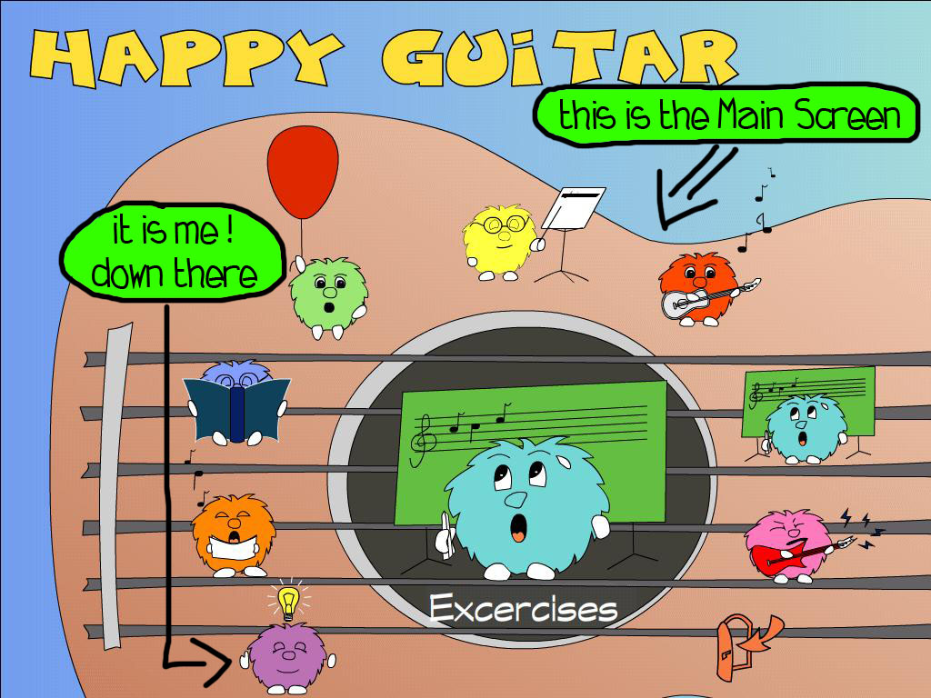
Do you see these colored guys, sitting on the guitar strings? That’s us, the Fluffy family. I’m the purple one, with a bulb hovering over my head. Wait, why is this bulb over my head? Who put it up there? Never mind, let’s explain basics.

Are you familiar with a music theory? No? Don’t worry yellow fluffy will explain it to you. Click on him.

Well, do you know the theory now? Well done! It’s time to learn how to play a guitar. Just click on the red fluffy and you’ll see learning lessons. I’ll explain details later.

Have you red through some of the lessons? Maybe it’s time to practice what you have learned. If you want to practice your play, select the cyan guy.

I know, I know, it is not that easy, is it. You surely are tired by now. What? Is it even boring? Well, let’s have some fun! Click on the green one, the one with a big red balloon, and play the game.

I see, you think you can play some serious music. Well, don’t waste any time and select orange fluffy. He’ll show you some songs, you can learn to play.

Now, if you want to learn some interesting information about guitars, history of guitars, and so on, you should click on the blue one and read the encyclopedia.

If your guitar doesn’t sound like it should, tune it. With a help of my pink brother you will be able to tune your guitar, so it plays just like it should.

That’s it. Now you know how to navigate through the main screen. Oh, I almost forgot. There’s also a door on the screen. Clicking on it will close Happy Guitar application.

What is this button for? :: Basic navigation
When navigating through the application, you’ll use some buttons and menus, also called control elements. Using these is really easy. You will probably be able to work with them intuitively. But to be sure, let’s explain it in detail.

After clicking on one of my brothers in the main screen, you’ll see next screen. Content of this screen depends on which one of us you have clicked. But there are some buttons and menus that are similar for all of the screens.

When you move your mouse cursor to the left edge of the application screen, main menu will roll out.
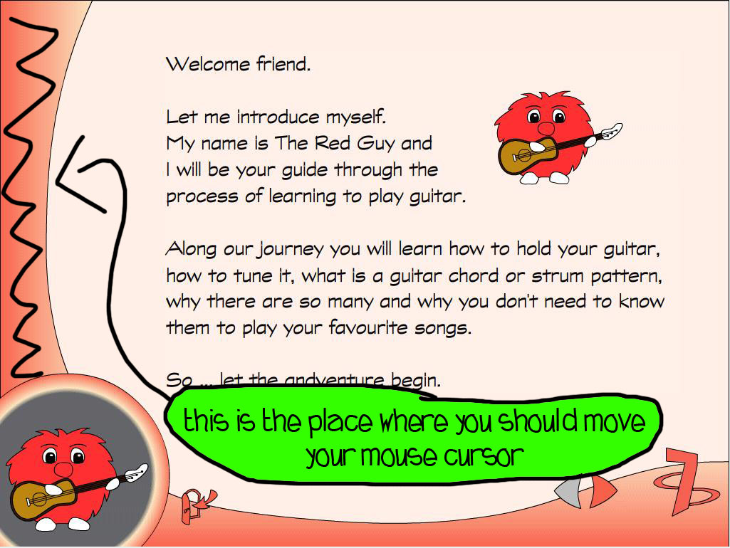
When you move your mouse out of the rolled menu, main menu will roll back and disappear.
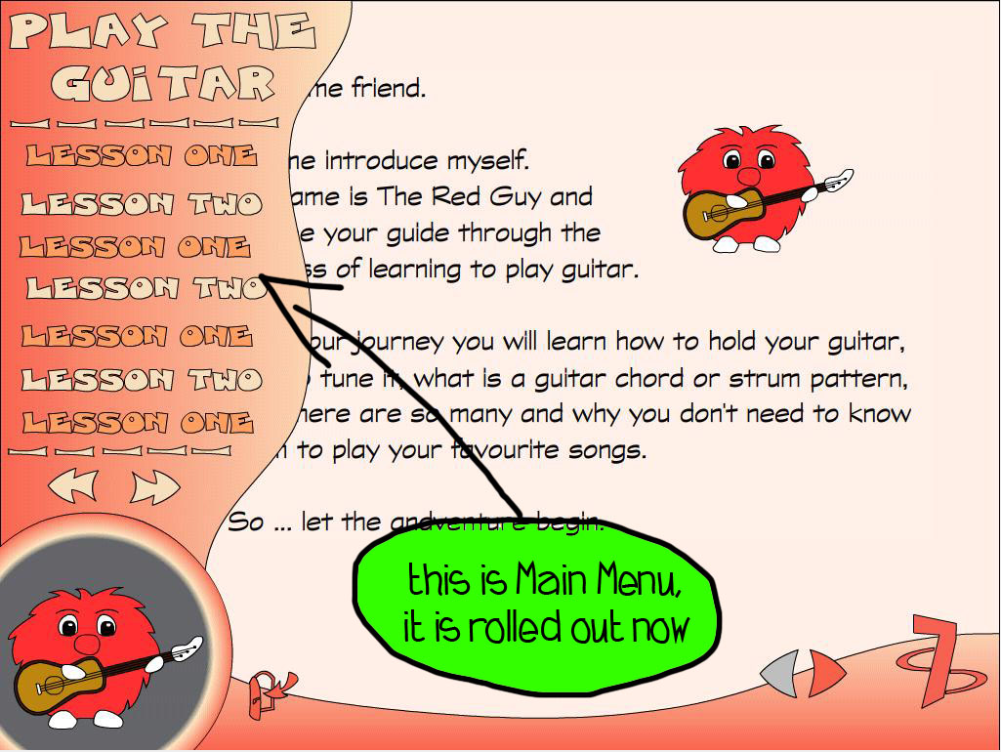
Let’s try it, shall we? If Happy Guitar isn’t open yet, open it. Click on the red fluffy. Now you can see Lessons screen. Move your mouse to the left, just on the left side bar. See? Main menu rolls out. Now move mouse to the right and menu disappears.

All right, you know how to access main menu now. Are you still in lesson screen? Move your mouse back to the left and roll out the menu. In the lesson screen menu, there is a list of available lessons. You’ll see lists such as this one in almost all of the screens. Selecting one menu item from the list will change the contents of screen on the right. Now, try selecting second menu item. See how contents change?

Each screen is divided into several pages. You can browse through the pages with arrows placed at bottom bar on the right side. Now, try it. Click several times at right arrow. That’s it, now you browse through the pages of the screen.

We are almost done with navigation. If you haven’t noticed yet, there is the door button on the bottom bar. It looks just like the one on the on the main screen, only a bit smaller. Clicking on this door will get you back to the main screen.
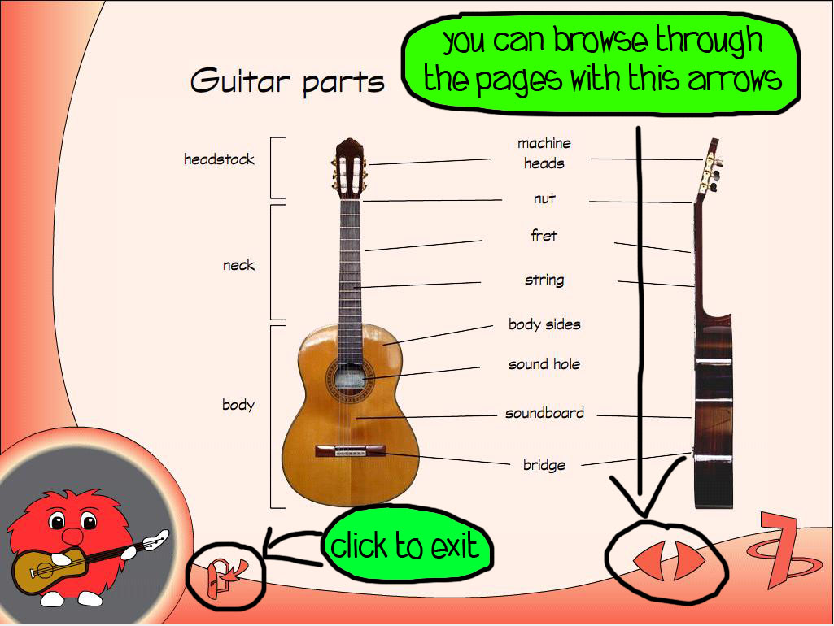
That’s it. Now you’re a navigation expert :) Remember, practicing is best way to get acquainted with user interface. Feel free to click on buttons, menu items and arrows... I’ll go now. I have to ask my creators, why the heck is this yellow bulb still over my head. See you later alligator!

What are these ... notes? :: Theory
Hello. My name is Yellow Fluffy. I will teach you basics of the music theory. But first things first. You need to know how to navigate through Theory screen. You see, there is main menu ... uhm, wait, I got a phone. “Yes, it’s me. Yes. Well, yes. OK, got it.” Sorry for that. That was my purple brother. He just told me that you already know how to navigate through the screens. So, I’m not going to tell you everything again. So, just in short, in the theory main menu there is a list of theory lessons. You ca browse through each lesson with arrows placed at the bottom right of the screen.

So, if you want to learn music theory, click on me on the main screen. I’m the one on the top. See you later.

I want to play a guitar. :: Lessons
Hi. I am red fluffy and I will teach you basic techniques of playing the guitar. You should focus on this part of Happy Guitar, because it is most important of all. I was told that you already know how to navigate through the screens, so there is not much more to say for me about it. You should just go step by step through the lessons, read carefully, and practice.

In lessons you’ll find scores of songs. The songs can by played simply by clicking on play button. If you want to stop playing a song, click on the stop button. There is also a sound recorder, where you can record your own play, and listen to it later.
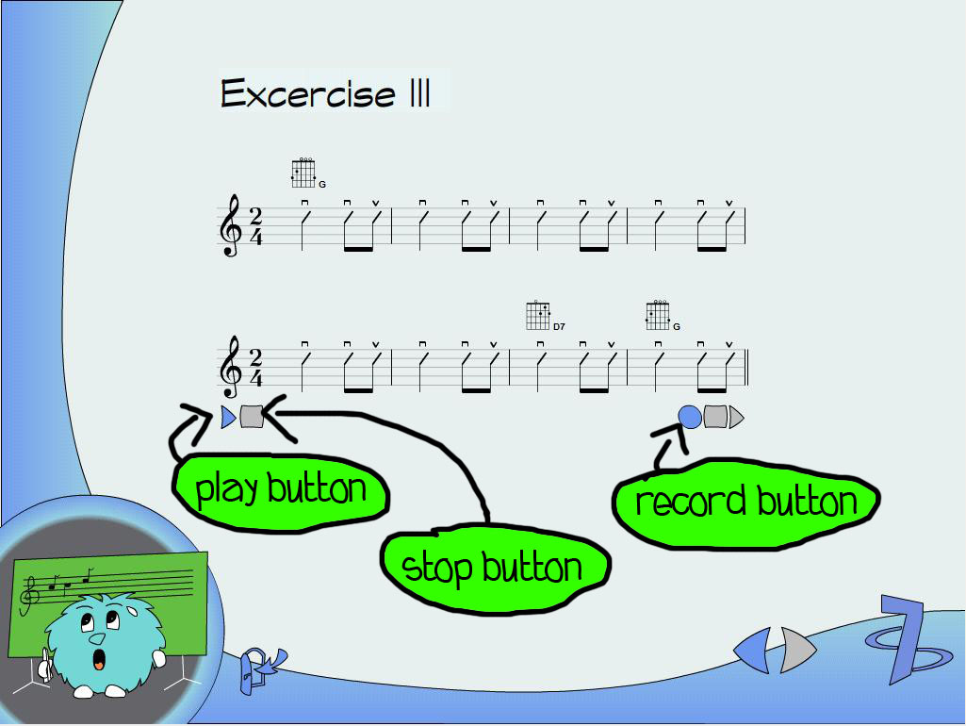
If you are ready to learn guitar play, you know where to find me. I am the red guy with a white guitar in my hands.

I need to practice more. :: Excercises
Hello my apprentice. My name is Cyan Fluffy and with my help you’ll be able to practice what you have already learned. All excercises and practices are available from main menu at Excercises screen.

You can access all excercises simply from roll menu on the left side of the screen. Each song is written as score. You can play the songs and record your play, just like you do in lessons.

Let’s have some fun! :: Game
Heeelooo !!! I am a green fluffy. First of all, don’t listen to my brothers, please. They are allways talking about going lessons, excercising, practicing and so on, and so on ... such a boooring thing to do. You know what, I got much more better idea. Let’s play a game with your guitar! Yes? Oh, you do not understand what am I talking about. Well, let me explain it to you.

It all began many years ago. Once, when I was on the trip, I suddenly found a labyrinth. And guess what. I got lost in it. I was trying to find way out, but with no success. To my luck, my brothers went to search for me. They found me, and got me out of the labyrinth. But it wasn’t over. This is where my labyrinth maaania began. I was so depressed, that I couldn’t find my way out, so I build my own labyrinth, just to prove myself that I am able to get out by myself. Since then I have aaalways tried to find my way out. Now, when you are here, would you pleeease help my find way out of labyrinth? Yes, you will? Cool, I’ll tell you how to do it.

You can find game at the main screen. To start the game, click on me. Remember I’m the green one with red balloon. To play the game, you should already have microphone attached to your computer. Put your microphone on the table in front of you. When you play a string to the microphone, sound will travel through the wires to your computer right to me. I will be able to hear it.

If you start the game, you’ll see on the game screen a labyrinth and a cross with four direction arrows. Take a look at the labyrinth. Can you see me there? Yes, it’s meee! I’m lost there agaaain. Now look at the four arrows cross. Each arrow has its direction and its letter. Each letter represents one string on your guitar.
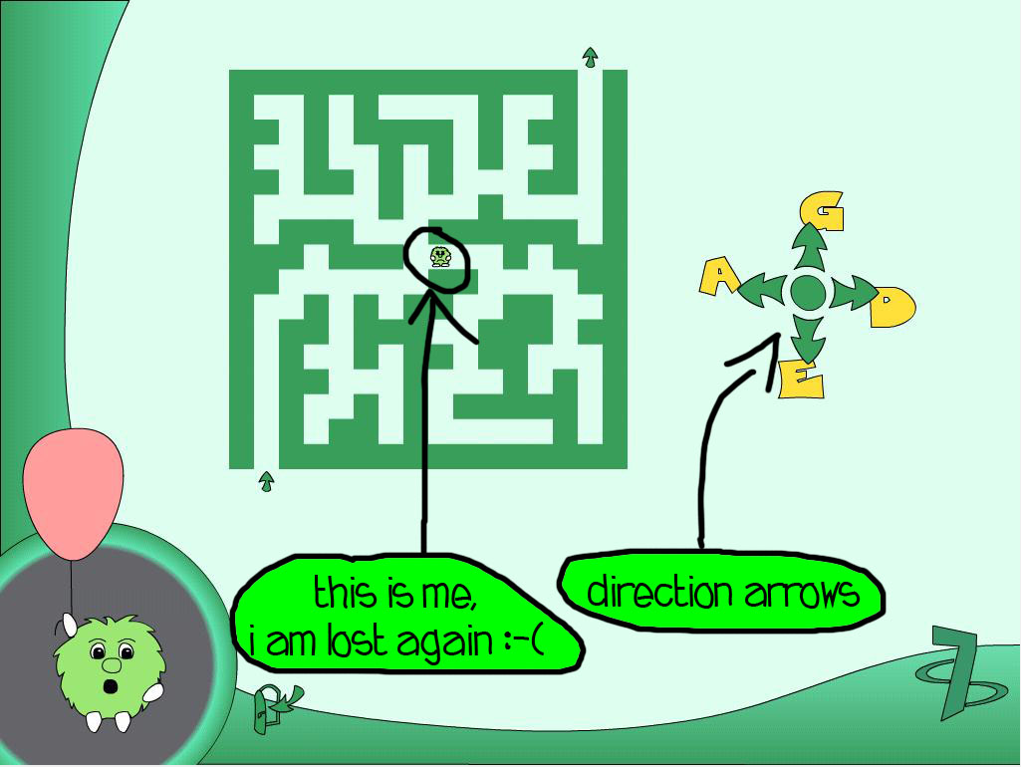
As you should already know, the point is to get me out of labyrinth. When you play the right string, I’ll hear and recognize it, and move in the right direction. I cannot see the exit of the labyrinth, but I can hear it. I can hear it from you! So, when you’ll play string, which letter is placed next to the up arrow, I will know, I have to move up. So please, get me ooout.

Now I can really play, can’t I? :: Songs
You surely want not only to play guitar, but also to sing while playing, don’t you. To do so, click on me. I am singing orange fluffy with papers in my hands. And what will you find when you click on me? There are many scores with famous songs. Each song has its chords and lyrics. You can select the one you wish and sing and play it.

To sing a song while playing it on a guitar, click on me, the orange fluffy, on the main screen.

What is this guitar actually? :: Encyclopedia
Good day to you! Let me introduce myself. My name is Mr. Blue. I have studied history of guitars for many years. Actually, I have studied all available information about guitars. I became so studied in the field of guitars that I decided to write down a Guitar Encyclopedia. You’ll find my encyclopedia after clicking on me at the main screen.

Ouch, this doesn’t sound well. :: Tuner
Does your guitar scream badly? Do people around you have to shut their ears? I got a solution for you! Tune your guitar with my ultimate Guitar Tuner! No, really, if you want to tune your guitar, click on me, the pink elephant, at the main screen.

To tune a guitar, you’ll need to connect a microphone to your computer, just like you did in the game. Now, you need to tune all six guitar strings. On the tuner screen you already see a guitar head and strings with their letters.

The first step is to click at first tuning key. Then play corresponding string on your guitar. When I’ll hear the tone you’ve just played, I’ll show you where to turn tuning key of your guitar. If you see red arrow, turn key strongly in arrows direction. If the arrow is green, turn the key just a bit. When you see green V sign, your string is well tuned. Then you should click on the next turning key and tune your next string, and so on...
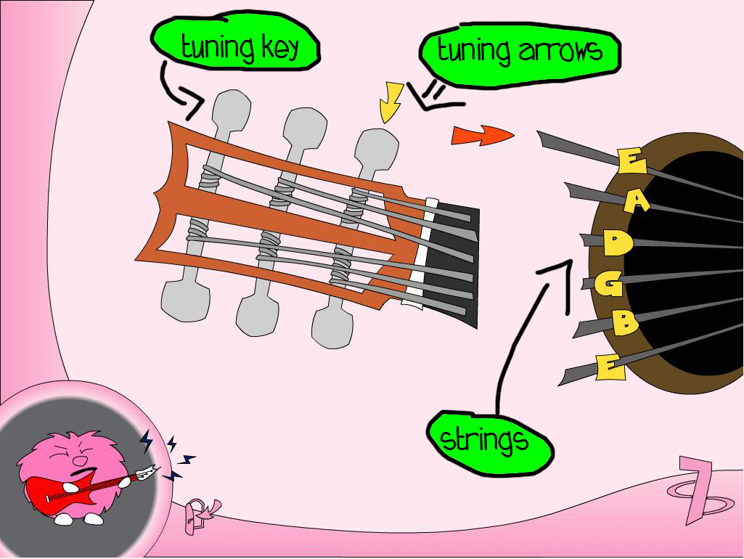
Remember, to tune your guitar, click the pink elephant on the main screen.

I’m lost, help me! :: Help
Hi there, it’s me again, purple fluffy. So, did you like my brothers? I hope they told you everything that you need. Yes? I know, I know, you didn’t catch everything. It’s lot of information for you. Don’t worry, in time, you’ll get acquainted with it. So, finally, if you’d like to read this tutorial again, just click on me.

By the way, did my pink brother mention some elephant? What? Did he? Oh no, not again. He thinks he’s an elephant. I should get him to a doctor before he starts eating grass again. And I can ask the doctor also about, uhm ... that bulb thing over my head.

